# DSP Project

## The reg & MUX module:

## The testbench:

Waveform:

## Main project code:

## Testbench:

First test:

Second & Third tests:

Cascade:

Do file:

## Waveforms:

First test:

Second test:

third test:

Cascade:

## Vivado:

Elaboration:

Schematic:

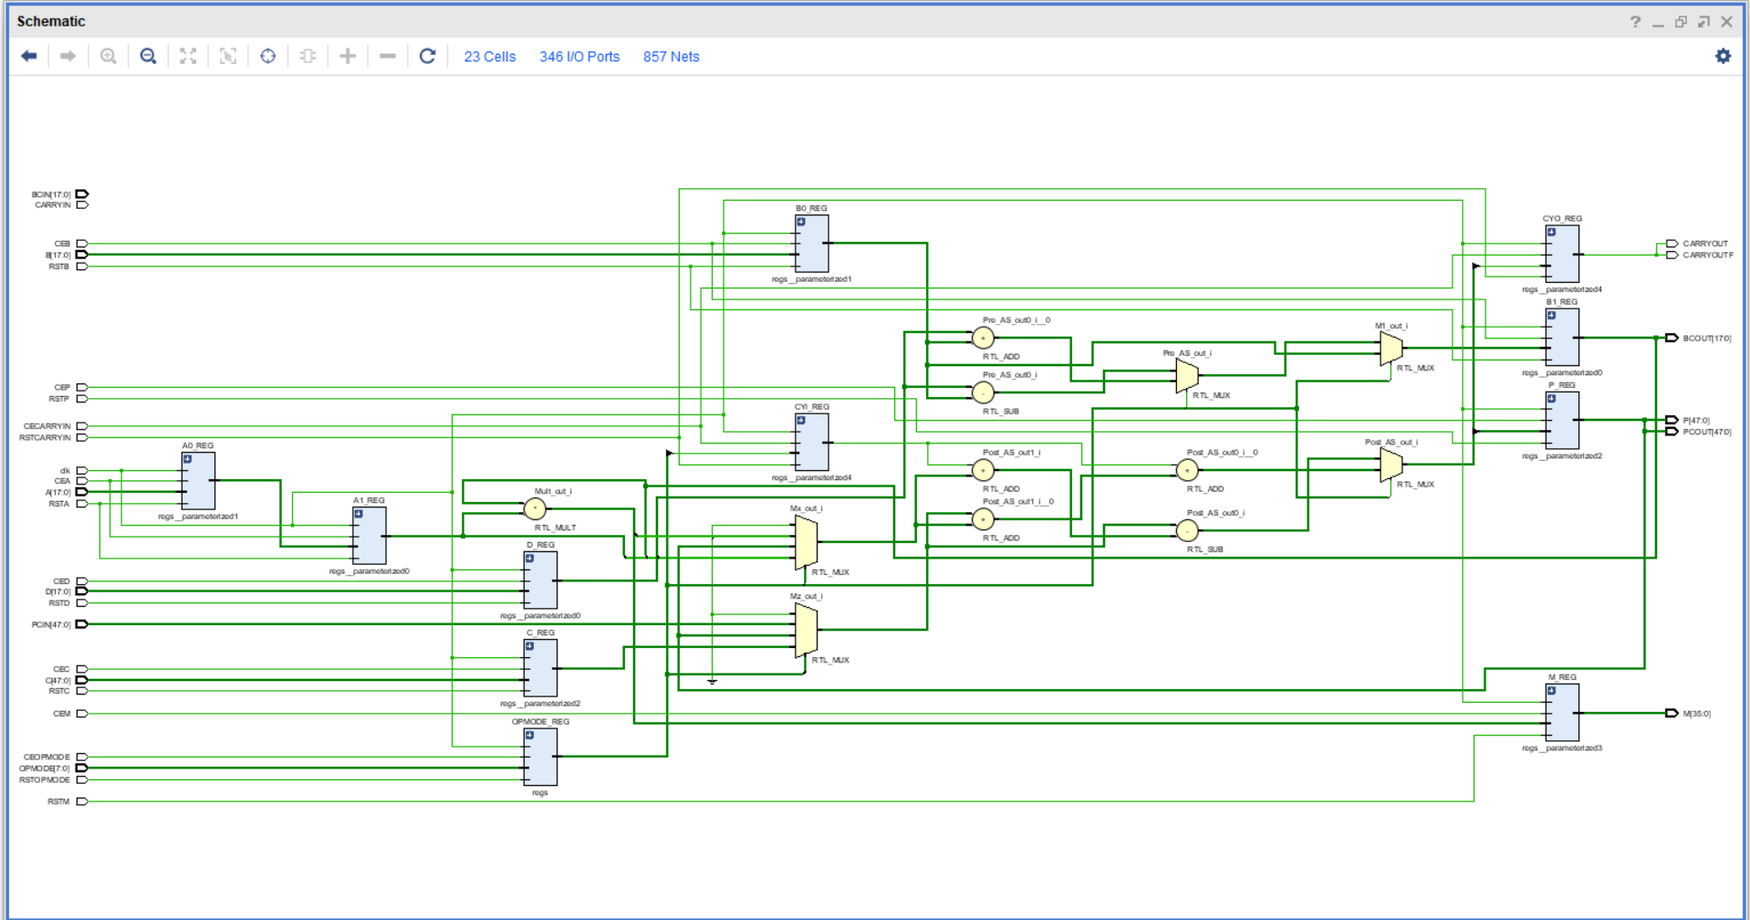

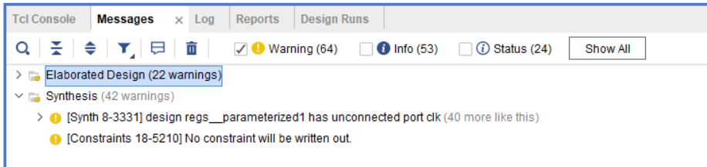

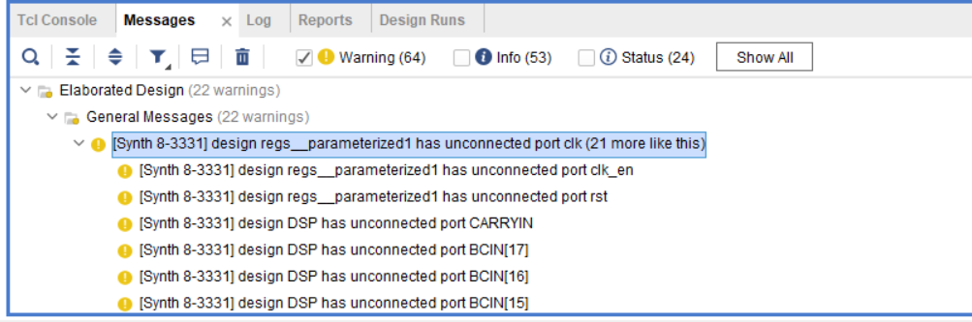

As the parameter default is direct not cascade so the input used in cascade are not used.

Synthesis:

Utilizations:

Timing report:

Messages:

Implementation:

Schematic:

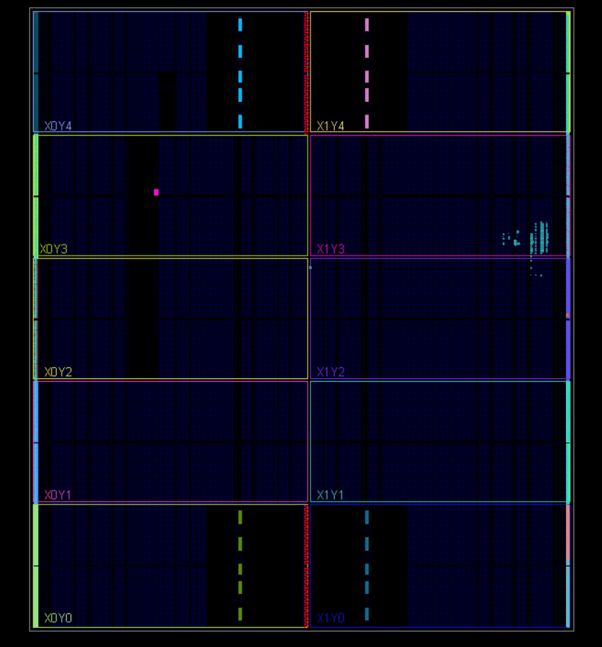

Utilization:

Timing:

Message:

Constrain file:

